Lab 4: Decisions and Boolean Logic
This lab accompanies Chapter 4 of Starting Out with Programming Logic & Design.

Name: _____________Joy Chudasama______________

Lab 4.1 –Logical Operators and Dual Alternative Decisions

Critical Review

The logical AND operator and the logical OR operator allow you to connect multiple Boolean expressions to create a compound expression.

The logical NOT operator reverses the truth of a Boolean expression.

When using the AND operator, both conditions must be true in order for the statements within an if to process.

When using the OR operator, either condition must be true in order for the statements within an if to process.

A dual alternative decision structure will execute one group of statements if its Boolean expression is true, or another group if its Boolean expression is false.

The general structure of an if then else statement is
If condition Then
Statement
Statement
Etc.
Else
Statement
Statement
Etc.
End If

Help Video: Double click the file to view video

This lab requires you to think about possible true and false conditions using if statements.

Step 1: Consider the following values set to variables.
- myAge = 32
- yourAge = 18
- myNumber = 81
- yourNumber = 17
- votingAge = 18
Step 2: Based on the values to the variables in Step 1, what is the expected output? Hint: The output will be either what is printed to the screen, or nothing. (Reference: Logical Operators, page 147).

The condition | Expected Output
If myAge == 31 AND yourAge < myAge Then  Display “My age is 31 and your age is less than that”  End If | Nothing
If myAge <= 35 AND myAge >= 32 Then  Display “My age is between 32 and 35”  End If | My age is between 32 and 35
If yourAge == votingAge OR yourAge > votingAge Then  Display “You can vote”  End If | You can vote
If myNumber == 83 OR yourNumber == 83 Then  Display “One of our numbers is 83”  End If | Nothing

Step 3: Based on the values to the variables in Step 1, what is the expected output? (Reference: Dual Alternative Decision Structures, page 125).

The condition | Expected Output
If myAge == 31 AND yourAge < myAge Then  Display “My age is 31 and your age is less than that”  Else  Display “Our ages do not qualify”  End If | Our ages do not qualify
If myAge <= 35 AND myAge >= 32 Then  Display “My age is between 32 and 35”  Else  Display “My age is not within that range”  End If | My age is between 32 and 35
If yourAge == votingAge OR yourAge > votingAge Then  Display “You can vote”  Else  Display “You cannot vote”  End If | You can vote
If myNumber == 83 OR yourNumber == 83 Then  Display “One of our numbers is 83”  Else  Display “83 is not our numbers”  End If | 83 is not our numbers
Lab 4.2 – Pseudocode: Dual Alternative Decisions

Critical Review

A dual alternative decision structure will execute one group of statements if its Boolean expression is true, or another group if its Boolean expression is false.

The general structure of an if then else statement is
If condition Then
Statement
Statement
Etc.
Else
Statement
Statement
Etc.
End If

Module Review

Recall the difference between a reference variable and a value variable. Reference variables are used in the following lab when the value of the variable is modified in the module. You’ll notice some parameter lists include the keyword Ref before the variable that is going to change within the module.

Help Video: Double click the file to view video

This lab requires you to think about the steps that take place in a program by writing pseudocode.

Recall the retail company program from Lab 3.2. The company now wants to modify their bonus portion to include different levels and types and eliminate the day off program. The new program is as follows:

A retail company assigns a $5000 store bonus if monthly sales are more than $100,000; otherwise a $500 store bonus is awarded. Additionally, they are doing away with the previous day off program and now using a percent of sales increase to determine if employees get individual bonuses. If sales increased by at least 4% then all employees get a $50 bonus. If they do not, then individual bonuses are 0.

Step 1: To accommodate the changes to the program, create the additional variables needed.
- Create a variable named storeAmount to hold the store bonus amount.
- Create a variable named empAmount to hold the individual bonus amount.
- Create a variable named salesIncrease to hold the percent of increase.

//Declare local variables
Declare Real monthlySales
Declare Real storeAmount
Declare Real empAmount
Declare Float salesIncrease

Step 2: The first module in the program is getSales(). Since this is still required, leave this module as is. This module should be written as follows:

//MODULE 1
//this module takes in the required user input
Module getSales(Real Ref monthlySales)
Display “Enter the total sales for the month.”
Input monthlySales
End Module

Step 3: The second module in the program was isBonus(). Since there are two types of bonuses now, rename this module and the module call to storeBonus(). Write an if then else statement within this module that will set the bonus amount to either 5000 or 500. Also, pass the variable storeAmount to the module as a reference. Complete the missing lines. (Reference: Dual Alternative Decision Structures, page 125).

//MODULE 2
//this module will determine what the bonus levels are
Module storeBonus(Real monthlySales, Real Ref storeAmount )
If monthlySales >=100000 Then
Set storeAmount = 5000

Set storeAmount = 500
End If
End Module

Step 4: Write a module that will ask the user to enter the percent of sales increase in decimal format. This module will have to accept salesIncrease as a reference. Complete the missing lines.

//MODULE 3
//this module takes in percent of increase in decimal
//format such as .02 for 2 percent.
Module getIncrease(Real Ref salesIncrease)
Display “Enter the percent of sales increase in decimal format .”
Input salesIncrease
End Module

Step 5: Write a module that will determine individual bonuses. If the sales increase percent was 4% or more, then all employees get a $50 bonus. If the sales increase was not reached, then the bonus amount should be set to zero. This module should be called empBonus and accept salesIncrease as a normal variable and empAmount as a reference.

//MODULE 4
//this module will determine what the bonus levels are
Module empBonus(Real salesIncrease , Real Ref empAmount )
If salesIncrease >= 4% Then
Set empAmount = 50
Else
Set empAmount = 0
End If
End Module

Step 6: Write a module that will print the store bonus and the employee bonus amount. Name this module printBonus() and pass the two necessary variables.

//MODULE 5
//this module will display store and employee bonus info.
Module printBonus(Real storeAmount, empAmount Real)
Display “The store bonus is $”, storeAmount
Display “The employee bonus is $”, empA2mount
End Module

Step 7: The final step in completing the pseudocode is to call all the modules with the proper arguments. Complete the missing lines.

Module main ()
//Declare local variables
Declare Real monthlySales
Declare Real storeAmount
Declare Real empAmount
Declare Real salesIncrease

//Function calls
Call getSales(monthlySales)
Call getIncrease(salesIncrease)
Call storeBonus(monthlySales, storeAmount )
Call empBonus(salesIncrease, empAmount )
Call printBonus(storeAmount, empAmount )

End Module

Lab 4.3 – Pseudocode: Nested Decision Structures

Critical Review

To test more than one condition, a decision structure can be nested inside another decision structure. This structure can become very complex, and often an if-then-else-if statement is used instead.

The general structure of the if-then-else-if statement is
If condition_1 Then
Statement
Statement
Etc.
Else If condition_2 Then
Statement
Statement
Etc.
Insert as many Else If clauses as necessary
Else
Statement
Statement
Etc.
End If

A case structure lets the value of a variable or an expression determine which path of execution the program will take. This is often used as an alternative to a nested if else decision.

Help Video: Double click the file to view video

The company now wants to add additional levels to their store and employee bonuses. The new levels are as follows:

Store bonuses:
If store sales are $80,000 or more, store bonus is $3000
If store sales are $90,000 or more, store bonus is $4000
If store sales are $100,000 or more, store bonus is $5000
If store sales are $110,000 or more, store bonus is $6000

Employee bonuses:
If percent of increase is 3% or more, employee bonus is $40
If percent of increase is 4% or more, employee bonus is $50
If percent of increase is 5% or more, employee bonus is $75

Step 1: Modify the storeBonus module to write a nested if else statement to set the new bonus levels. Complete the missing lines. (Reference: The if-then-else Statement, page 140).

//MODULE 2
//this module will determine what the bonus levels are
Module storeBonus (Real monthlySales, Real Ref storeAmount)
If monthlySales >= 110000 Then
Set storeAmount = 6000
Else If monthlySales >= 100000 Then
Set storeAmount = 5000
Else if monthlySales >= 90000 Then
Set storeAmount = 4000
Else if monthlySales >= 80000 Then
Set storeAmount = 3000
Else
Set storeAmount = 0
End If
End Module

Step 2: Modify the empBonus module to write a nested if else statement to set the new bonus levels. Complete the missing lines. (Reference: The if-then-else Statement, page 140).

//MODULE 4
//this module will determine what the bonus levels are
Module empBonus (Real salesIncrease, Real Ref empAmount)
If salesIncrease >= .05 Then
Set empAmount = 75
Else If salesIncrease >= .04 Then
Set empAmount = 50
Else if salesIncrease >= .03 Then
Set empAmount = 40
Else
Set empAmount = 0
End If
End Module

Step 3: Modify Module 5 by adding an if statement that will print a message if both the store bonus and the employee bonus are the highest amounts possible. (Reference: Logical Operators, page 147).

//MODULE 5
//this module will display store and employee bonus info.
Module printBonus(Real storeAmount, Real empAmount)
Display “The store bonus is $”, storeAmount
Display “The employee bonus is $”, empAmount
If storeAmount == 6000 AND empAmount == 75 Then
Display “Congrats! You have reached the highest bonus amounts possible!”
End If
End Module

Lab 4.4 – Flowcharts
Critical Review

A dual alternative decision structure has two possible paths of execution – one path is taken if a condition is true, and the other path is taken if the condition is false.

A diamond with a true and false value is used in flowcharting a dual alternative decision structure.
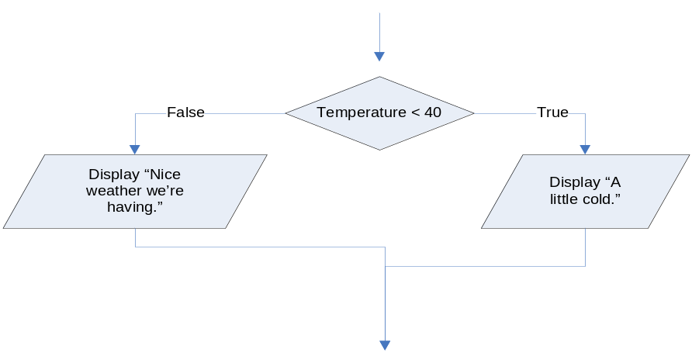
Nested if-then-else flowcharts look as follows:
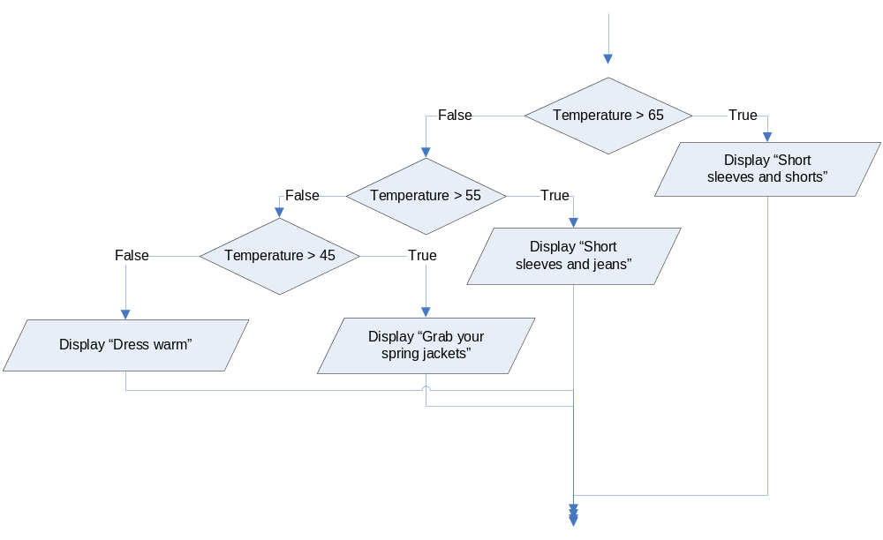
Help Video: Double click the file to view video

This lab requires you to convert your pseudocode in Lab 4.3 to a flowchart. Use an application such as Raptor or Visio.

Step 1: Start Raptor and save your document as Lab 4-4. The .rap file extension will be added automatically. Start by adding a Comment box that declares your variables.

Step 2: The next step in your flowchart should be to call your methods. Main should look as follows. Be sure to click yes to add new tabs for each module.
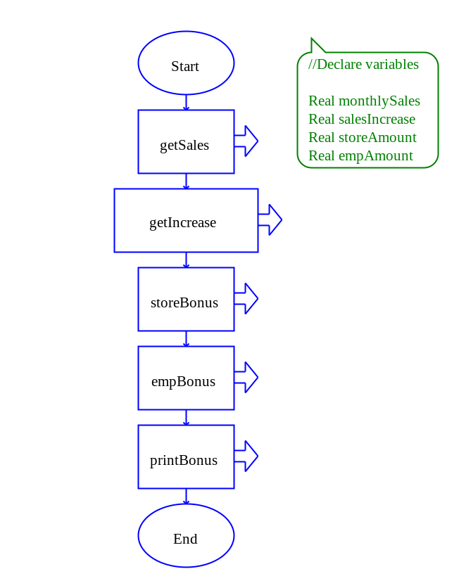

Step 3: Click on the getSales tab and add the necessary code to enter the monthly sales. Your getSales method might look like the following:
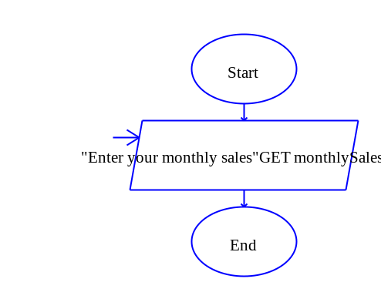
Step 4: Click on the getIncrease tab and add the necessary code to enter the percent of increase in sales. Since percentages can be entered differently, you should specify the method to the user. Either method is fine, as long as you specify. One method is as follows:
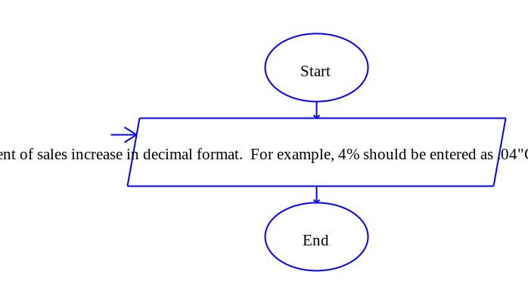
Here is a different method whereas the number entered is divided by 100:
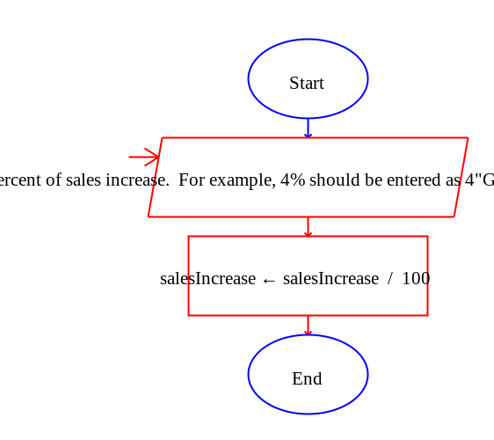
Step 5: Click on the storeBonus tab and add the nested if-then-else statement from Lab 4.3, Step 1. Do not forget the final else of setting storeAmount to 0. The start of your module should look as follows, and you should have a total of four decisions:
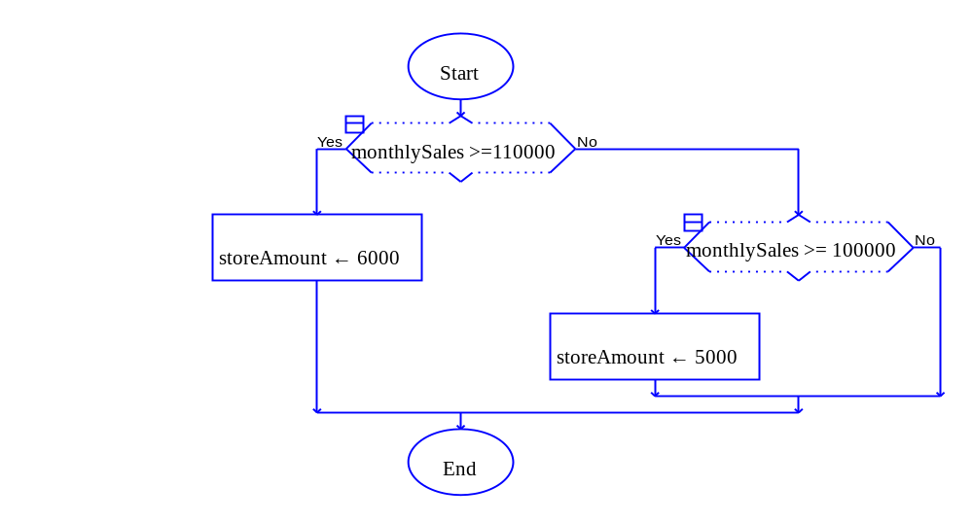
Step 6: Click on the empBonus tab and add the nested if-then-else statement from Lab 4.3, Step 2. Do not forget the final else of setting empAmount to 0. The start of your module should look as follows, and you should have a total of three decisions:
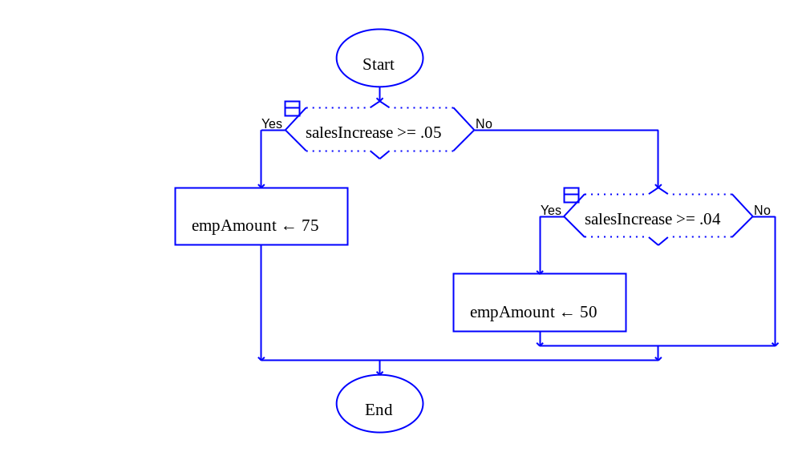

Step 7: Click the printBonus tab and add the necessary code from Lab 4.3, Step 3. The module should look as follows:

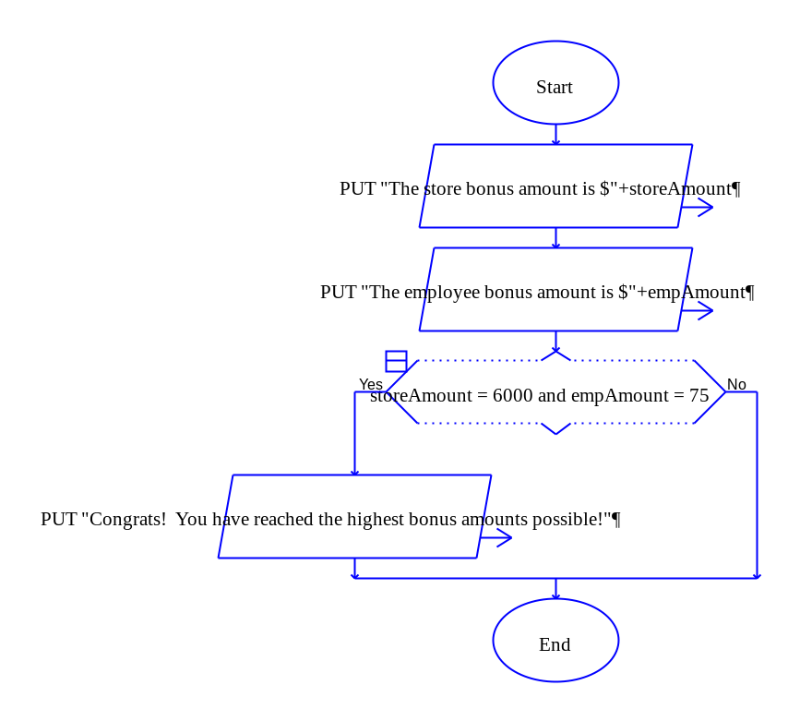
Step 8: When your program is complete, test the following monthly sales and sales increases to ensure that the output matches the following. If your output is different, then review your code.

Input Values | Expected Output
monthlySales = 120500  salesIncrease = 5 | The store bonus amount is $6000  The employee bonus amount is $75  Congrats! You have reached the highest bonus amounts possible!
monthlySales = 93400  salesIncrease = 5 | The store bonus amount is $4000  The employee bonus amount is $75
monthlySales = 75000  salesIncrease = 1.5 | The store bonus amount is $0  The employee bonus amount is $0
monthlySales = 82000  salesIncrease = 3.6 | The store bonus amount is $3000  The employee bonus amount is $40
monthlySales = 125000  salesIncrease = 4.5 | The store bonus amount is $6000  The employee bonus amount is $50

Step 9: The final step is to insert your finished flowchart in the space below. Inside Raptor, select File and the Print to Clipboard from the menu. Inside Word in the space below, select Edit and Paste. You will have to do this for each module you created.

PASTE FLOWCHART HERE

- main()
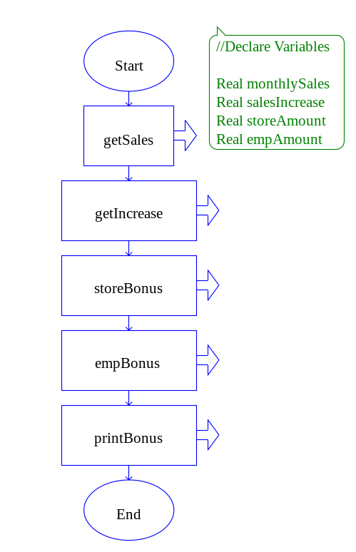
2. getSales()
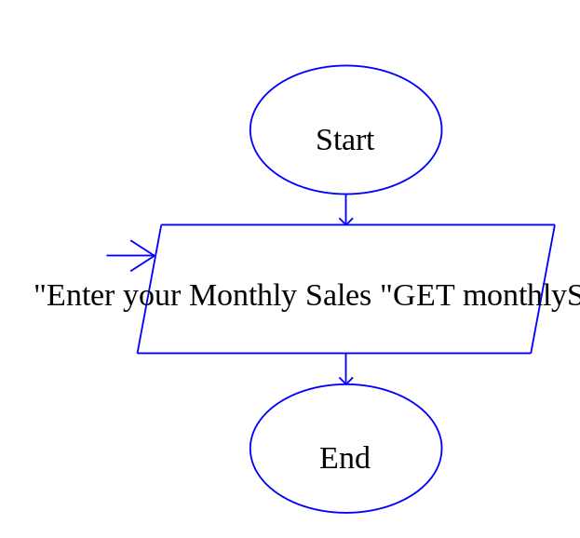

3. getIncrease()
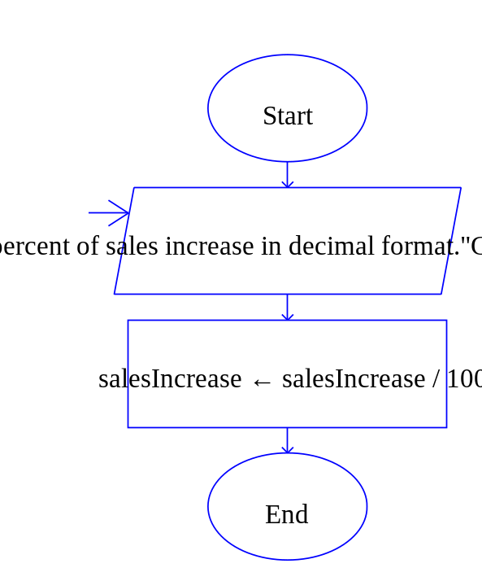
4. storeBonus()
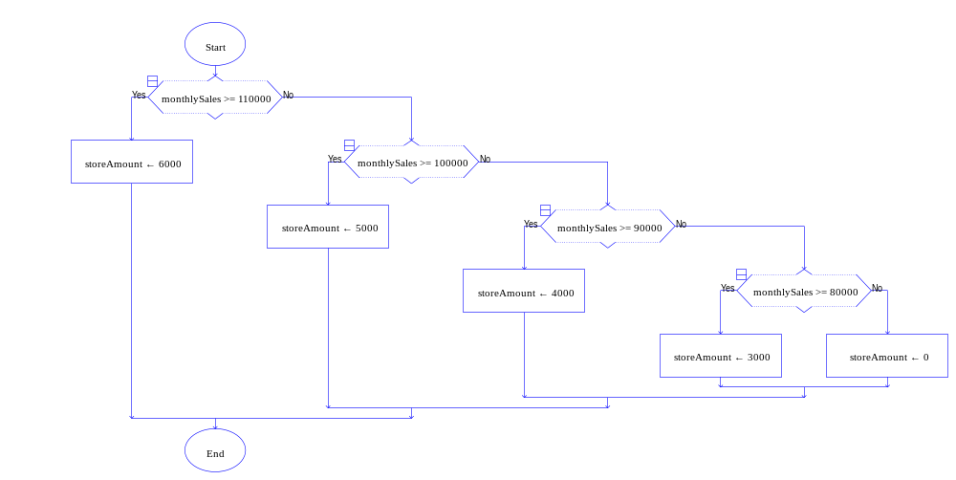
5. empBonus()

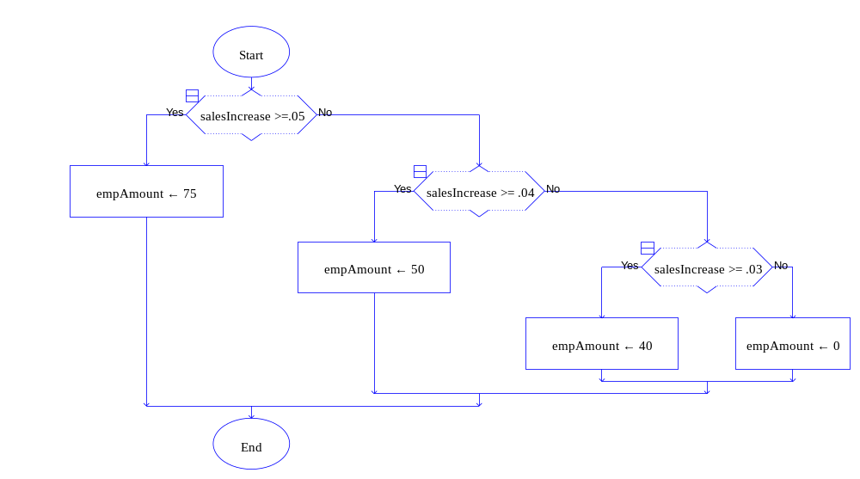
6. printBonus()

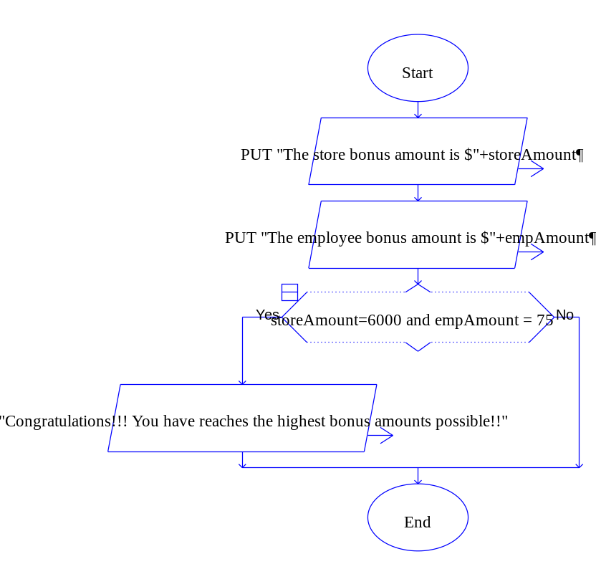
7. Output

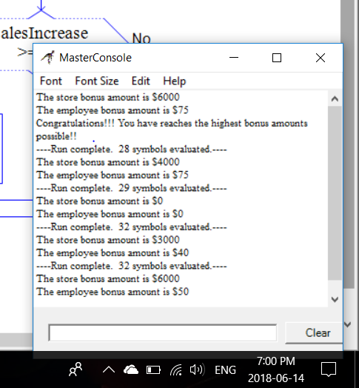

Lab 4.5 – Python Code
Critical Review

In code we write a dual alternative decision structure as an if-else statement. Here is the general format of the if-else statement:

if condition:
statement
statement
etc.
else:
statement
statement
etc.

Here is the general format of the if-elif-else statement:

if condition_1:
statement
statement
etc.
elif condition_2:
statement
statement
etc.

Insert as many elif clauses as necessary…

else:
statement
statement
etc.

The logical operators and, or, and not are used in Python to connect Boolean expressions.

Help Video: Double click the file to view video

Step 1: Start the IDLE Environment for Python. Prior to entering code, save your file by clicking on File and then Save. Select your location and save this file as Lab4-5.py. Be sure to include the .py extension.

Step 2: Document the first few lines of your program to include your name, the date, and a brief description of what the program does.

Step 3: Start your program with the following code:

#Lab 4-5
#The main function
def main():
monthlySales = getSales() #call to get sales

#This function gets the monthly sales
def getSales():
monthlySales = input('Enter the monthly sales $')
monthlySales = float(monthlySales)
return monthlySales

#This function gets the percent of increase in sales
def getIncrease():

#This function determines the storeAmount bonus
def storeBonus():

#This function determines the empAmount bonus
def empBonus():

#This function prints the bonus information
def printBonus():

#calls main
main()

Step 4: Under the getIncrease function, add the necessary code to allow the user to input sales increase. Your code might look as follows:

#This function gets the percent of increase in sales
def getIncrease():
salesIncrease = input('Enter percent of sales increase. For example 4% should be entered as 4: ') salesIncrease = float(salesIncrease)
salesIncrease = salesIncrease / 100
return salesIncrease

Step 5: Under the call to getSales(), add a function call to getIncrease().

salesIncrease = getIncrease() #call to get sales increase

Step 6: Under the storeBonus function, add the necessary code so that the program will determine what the proper storeAmount variable should have. This function might look as follows:

#This function determines the storeAmount bonus
def storeBonus(monthlySales):
if monthlySales >=110000:
storeAmount = 6000
elif monthlySales >=100000:
storeAmount = 5000
elif monthlySales >=90000:
storeAmount = 4000
elif monthlySales >=80000:
storeAmount = 3000
else:
storeAmount = 0
return storeAmount

Step 7: Under the call to getIncrease(), add a function call to storeBonus().

#call to get the store bonus
storeAmount = storeBonus(monthlySales)

Step 8: Repeat the similar process in step 6 and 7 for writing the empBonus() function and making a call to it. Recall that this function uses salesIncrease to determine empAmount.

Step 9: Code the printBonus() function to print the storeAmount and empAmount. This function might look as follows:

#This function prints the bonus information
def printBonus(storeAmount, empAmount):
print 'The store bonus amount is $', storeAmount
print 'The employee bonus amount is $', empAmount
if storeAmount == 6000 and empAmount == 75:
print 'Congrats! You have reached the highest bonus amounts possible!'

Step 10: Under the call to empBonus(), add a function call to printBonus. This call might look as follows:

printBonus(storeAmount, empAmount) #call to print amounts

Step 11: Click Run and Run Module to see how your program processes. Test the following values to verify the expected output.

Input Values | Expected Output
monthlySales = 120500  salesIncrease = 5 | The store bonus amount is $ 6000  The employee bonus amount is $ 75  Congrats! You have reached the highest bonus amounts possible!
monthlySales = 93400  salesIncrease = 5 | The store bonus amount is $4000  The employee bonus amount is $75
monthlySales = 75000  salesIncrease = 1.5 | The store bonus amount is $0  The employee bonus amount is $0
monthlySales = 82000  salesIncrease = 3.6 | The store bonus amount is $3000  The employee bonus amount is $40
monthlySales = 125000  salesIncrease = 4.5 | The store bonus amount is $6000  The employee bonus amount is $50

Step 12: Execute your program so that it works and paste the final code below

PASTE CODE HERE

'''
Name : Joy Chudasama
Date : 14th June,2018
Description : In this program I'm going to use Nested If Decision Structure.
When we want to put multiple conditions then we can use Nested If Decision Structure.
'''
def main():
getSales()
getIncrease()
storeBonus(monthlySales)
empBonus(salesIncrease)
printBonus(storeAmount,empAmount)
def getSales():
global monthlySales
monthlySales=int(input("\nEnter the Monthly Sales :"))
return monthlySales
def getIncrease():
global salesIncrease
salesIncrease=float(input("Enter the Percent Of Sales Increase In Decimal Format :"))
salesIncrease = salesIncrease / 100
return salesIncrease
def storeBonus(monthlySales):
global storeAmount
if monthlySales>=110000:
storeAmount=6000
elif monthlySales>=100000:
storeAmount=5000
elif monthlySales>=90000:
storeAmount=4000
elif monthlySales>=80000:
storeAmount=3000
else:
storeAmount=0
return storeAmount
def empBonus(salesIncrease):
global empAmount
if salesIncrease>=.05:
empAmount=75
elif salesIncrease>=.04:
empAmount=50
elif salesIncrease>=.03:
empAmount=40
else:
empAmount=0
return empAmount
def printBonus(storeAmount,empAmount):
print("\nThe Store Bonus Is $",storeAmount)
print("The Employee Bonus Is $",empAmount)
if storeAmount == 6000 and empAmount == 75:
print("\n\t\t\t\t\tCongratulations!!!")
print("\n\tYou've Reached The Highest Bonus Amounts Possible!!")
main()

Lab 4.6 – Programming Challenge 1 – Tip, Tax, and Total

Write the Pseudocode, Flowchart, and Python code for the following programming problem.

Help Video: Double click the file to view video

Recall the Tip, Tax, and Total program from Lab 2.6. Modify your program to include new requirements.

Write a program that will calculate a XXX% tip and a 6% tax on a meal price. The user will enter the meal price and the program will calculate tip, tax, and the total. The total is the meal price plus the tip plus the tax. Your program will then display the values of tip, tax, and total.

The restaurant now wants to change the program so that the tip percent is based on the meal price. The new amounts are as follows:

Meal Price Range | Tip Percent
.01 to 5.99 | 10%
6 to 12.00 | 13%
12.01 to 17.00 | 16%
17.01 to 25.00 | 19%
25.01 and more | 22%

The Pseudocode

TYPE PSEUDOCODE HERE

Module main ()
//Declare Local Variables
Declare Float mealPrice
Declare Float tax
Declare Float tip
Declare Float total

//Call Modules
Call getPrice()
Call calcTax(mealPrice)
Call calcTip(mealPrice)
Call calacTotal(mealPrice, tax, tip)
Call printOutput(tax, tip, total)
End Module

Module getPrice()
Display “Enter the Meal Price :”
Input mealPrice
End Module

Module calacTax(Float Ref mealPrice)
Set tax = mealPrice*.06
End Module

Module calcTip(Float Ref mealPrice)
If mealPrice >= .01 AND mealPrice <= 5.99 Then
Set tip = mealPrice * .10
Elif mealPrice >= 6 AND mealPrice <= 12 Then
Set tip = mealPrice * .13
Elif mealPrice >= 12.01 AND mealPrice <= 17 Then
Set tip = mealPrice * .16
Elif mealPrice >= 17.01 AND mealPrice <= 25 Then
Set tip = mealPrice * .19
Else
Set tip = mealPrice * .22
End Module

Module calcTotal(Float Ref mealPrice, Float Ref tax, Float Ref tip)
Set total = mealPrice + tax + tip
End Module

Module printOutput(Float tax, Float tip, Float total)
Display “The tip on your meal price is ”, tip
Display “The tax on your meal price is ”, tax
Display “The total is ”, total
End Module

The Flowchart

PASTE FLOWCHART HERE

- main ()
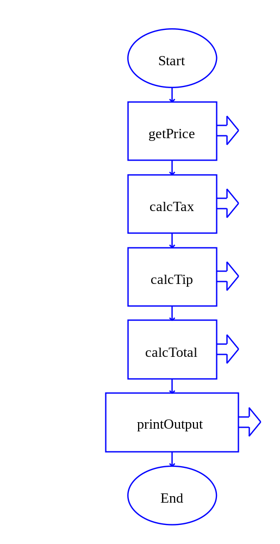
2. getPrice ()

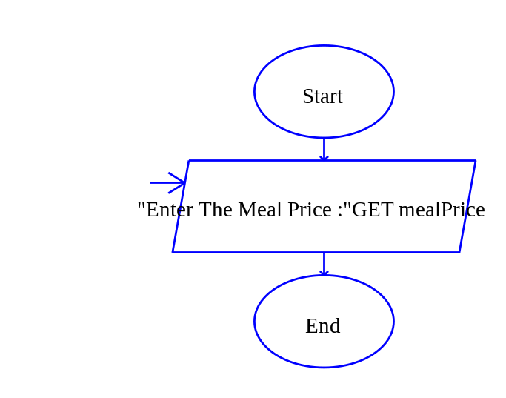

3. calcTax ()
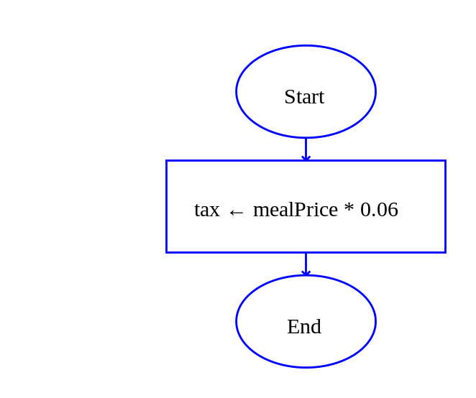

4. calcTip ()

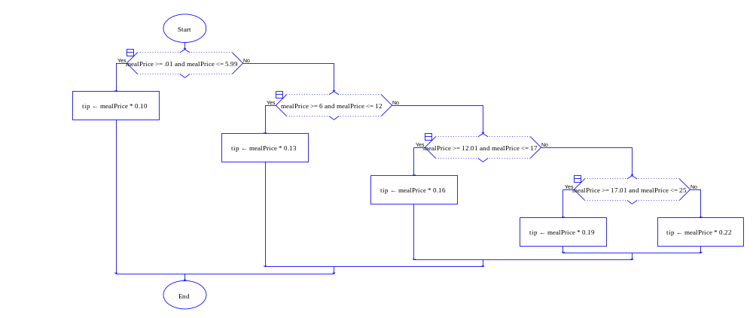

5. calacTotal ()

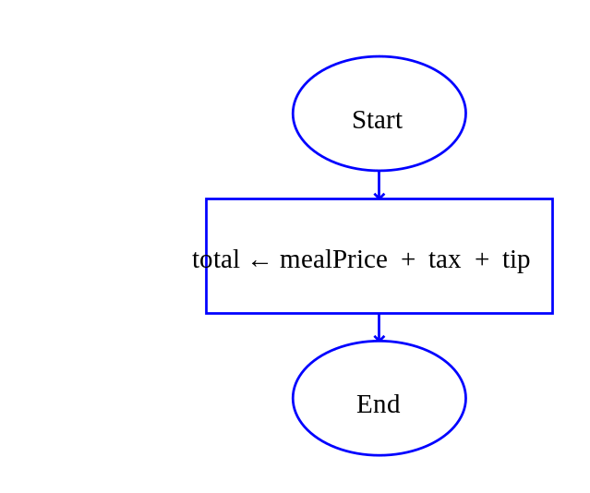
6. printOutput ()
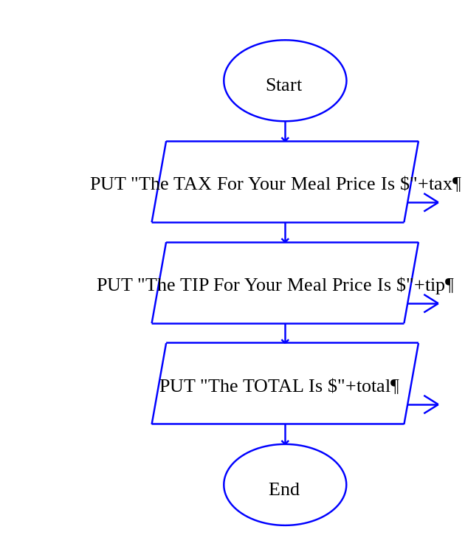

The Python Code

PASTE CODE HERE

def main():
getPrice()
calcTax(mealPrice)
calcTip(mealPrice)
calcTotal(mealPrice,tax,tip)
printOutput(tax,tip,total)
def getPrice():
global mealPrice
mealPrice=float(input("\n\nEnter the Meal Price :"))
return mealPrice
def calcTax(mealPrice):
global tax
tax=mealPrice*.06
return tax
def calcTip(mealPrice):
global tip
if mealPrice >= .01 and mealPrice <= 5.99:
tip=mealPrice * .10
elif mealPrice >= 6 and mealPrice <= 12:
tip=mealPrice * .13
elif mealPrice >= 12.01 and mealPrice <= 17:
tip=mealPrice * .16
elif mealPrice >= 17.01 and mealPrice <= 25:
tip=mealPrice * .19
else:
tip=mealPrice * .22
return tip
def calcTotal(mealPrice,tax,tip):
global total
total=mealPrice+tax+tip
return total
def printOutput(tax,tip,total):
print("\n****************************************")
print("\nThe Tax On Your MealPrice Is $ %.2f"%tax)
print("The Tip On Your MealPrice Is $%.2f"%tip)
print("The Total Is $%.2f"%total)
print("\n****************************************")
main()

